EENG 5420

Antenna Theory & Design

Project Report

Due: 05/07/2025

# Guided By

# DR. Hung Luyen

# Submitted By

# Hemanth Kanaparthi

**(11710268)**

# Sanjay Bhaskar

**(11708315)**



**Table of Contents:**

|  |
| --- |
| 1. **Abstract** |
| 1. **Introduction** |
| 1. **Approach** |
| 1. Literature Review 2. Selection of Antenna Structure and Design Strategy |
| 1. **Antenna Design** |
| * Antenna Topology * Design Parameters * Mechanism for Dual-Band Operation * Polarization and Feeding Structure |
| 1. **Simulation Results** |
| * Antenna Model in HFSS * S-Parameter Results (|S₁₁|) * 3D Radiation Patterns * Gain vs. Frequency Graph * Realized Gain vs. Frequency Graph |
| 1. **Conclusion** |
| 1. **References** |

1. **ABSTRACT:**

This project aims to design a dual-band antenna for Wi-Fi applications. Below are the guidelines for the design project.

The objective is to design an antenna that meets the following specifications:

1. Frequency ranges of operation: the antenna has two operating bands of 2.4-2.5 GHz (lower band) and

5.1- 5.9 GHz (higher band).

2. |𝑆11| ≤ −10 dB (with a reference impedance of 50 Ω) over the entire frequency bands.

3. Polarization: linear polarization (either vertical or horizontal polarization).

4. Gain: at least 6.0 dBi over the entire band.

5. Maximum physical dimensions: 100 mm × 100 mm× 50 mm.

1. **INTRODUCTION:**

When an antenna is polarized in a particular direction, it means that the wave it transmits (radiates) is polarized as well. It is presumed that the polarization is in the direction of maximal gain when the direction is left unspecified. In actuality, the direction from the antenna's center can affect the polarization of the energy emitted, resulting in distinct polarizations in various regions of the radiation pattern.

A radiated electromagnetic wave's polarization is determined by the relative size and direction of its electric-field vector over time. It is specifically the shape that is traced along the path of wave propagation by the extremity of this vector at a fixed location in space as a function of time. The polarization is represented by this traced form, or curve.

Polarization is classified as linear, circular, or elliptical. If the vector that describes the electric field at a point in space as a function of time is always directed along a line, the field is said to be linearly polarized. Linear and circular polarizations are special cases of elliptical and they can be obtained when the ellipse becomes a straight line or a circle. Clockwise rotation of the electric-field vector is also designated as right-hand polarization and counterclockwise as left-hand polarization. The instantaneous field of a plane wave, traveling in the negative z direction, can be written as

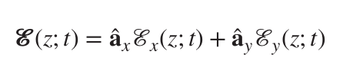

For the wave to have linear polarization, the time-phase difference between the two components must be Δ𝜙 =𝜙y−𝜙x =n𝜋, n=0,1,2,3, …

The objective of this project is to design a dual-band antenna. We selected a microstrip patch antenna that can perform efficiently across the given Wi-Fi bands of 2.4-2.5 GHz and 5.1-5.9 GHz. These frequency bands are generally used in present wireless communication systems. Specifications include dual-band operation, linear polarization, a minimum gain of 6 dBi in both bands, and compact physical dimensions of not more than 100 mm × 100 mm × 50 mm. The antenna was designed and simulated by using Ansys Electric HFSS.

For achieving dual-band antenna behaviour, a microstrip patch antenna with a rectangular shape has been improved with an arced H-shaped slots at a particular position, which allows the antenna to get more gain and S11 parameters <-10dB. The above strategy employs dual resonant routes, which produce two different resonant frequencies within the target (given) bands. The ultimate design has an adequate impedance compatibility (|S11| < -10 dB), essential gain, and polarization that is linear.

1. **APPROACH:**
2. **LITERATURE REVIEW:**

This course creates a platform to learn every single aspect in a detailed manner of explanation regarding various topics in antenna design, types, and functionality. Such as a two-element array, a linear array, a Broadside array, Ordinary end fire array, a Hasen Woodyard End-Fire array, a Binomial Array, a Dolph-Tschebycheff array, a planar array antenna. Additionally, patch antennas, their feeding techniques, etc.

**Two-element array:**

An antenna system is designed of two identical elements, such as (infinitesimal horizontal dipole. That is spatially differentiated, typically along a straight line, and electrically excited (with the same or different phase and amplitude) to establish together radiation pattern.

**Linear array:**

It is a system where several antenna elements are placed in a straight line along a single axis.

**Broadside array:**

This array comes under a linear antenna array designed in a way that its maximum radiation is directed perpendicular to the axis of the array. The Ө is equal to 90 degrees. To make this possible, the phase difference **(𝛽)** between two elements is zero, Element spacing must be less than one wavelength **(𝜆) to avoid** grating lobes. In case the d ≥ 𝜆 grating lobes appear within the visible range, that can lead to multiple radiation maxima, which is unwanted.

**Ordinary end fire array:**

End fire array comes under linear antenna array in which the maximum radiation is along the axis of the array **𝜃₀ = 0° or 180°,** to achieve directional radiation. The progressive phase shift **𝛽**





Between the elements given above, to achieve the radiation in one direction, the element spacing must be less than half of the wavelength to avoid grating lobes.

**Hansen-Woodyard End-Fire Arrays:**

The end-fire arrays (EFA) have relatively large HPBW as compared to broadside arrays. To enhance the directivity of an end-fire array, Hansen and Woodyard proposed that the phase shift of an ordinary EFA.

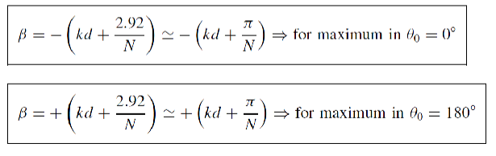

**Binomial Array:**

This is a type of linear array, where the amplitude of each element is organized according to its coefficient of the binomial theorem.

**Dolph-Tschebycheff array:**

Dolph-Tschebycheff (DT) arrays are a compromise between the binomial arrays and uniform arrays. The excitation coefficient of this array belongs to the Tschebyshev   
(Chebyshev) polynomial coefficients.

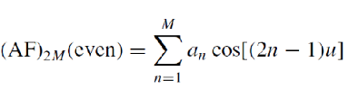

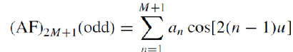

**Planar Array Antenna:**

This is an array antenna where the individual radiating elements are allocated in a 2-dimensional rectangular grid.

**Patch Antennas:**

The patch antenna is also said to be a microstrip antenna that consists of metallic patches (with various sizes and shapes) that are printed on one side of the substrate, and the other side of the substrate is completely covered with the ground plane. These antennas have different advantages, such as low cost and easy design, are suitable for planar and non-planar surfaces, and have a wide range of radiation patterns, gain, and polarization.

**Feeding Techniques:**

The feeding techniques are the methods for transmitting radio frequency (RF) power to the antenna and to make sure to efficient radiation.

There are four types:

* Microstrip line feed
* Aperture-coupled feed
* Probe feed
* Proximity-coupled feed

As we learnt from previous lectures and research we decided to use slot-loaded microstrip antennas because they are very efficient in achieving dual-band operation with maintaining the small size. Designs featuring U-slots, E-slots, and H-slots will definitely achieve the required parameters for Wi-Fi bands.

This antenna uses arced H-slots in its design because they allow it to support two distinct resonant modes. These slots effectively disturb the current distribution just enough to split the resonance between 2.4 GHz and 5.5 GHz without needing any additional layers. We designed in way that patch is fabricated on an FR4 substrate (Dielectric permittivity of 4.4) with a thickness of 1.6 mm. The feed of this antenna is implemented using a microstrip line which is 50Ω. The antenna is designed in Ansys Electronic Desktop Student 2024 R2 HFSS

1. **Selection of Antenna Structure and Design Strategy**

The design of the antenna was driven by the need to support dual-band wireless communication, specifically within the 2.4–2.5 GHz and 5.1–5.9 GHz frequency ranges. The design goals also included achieving a minimum gain of 6.0 dBi, maintaining linear polarization, and ensuring return loss values of |S₁₁| ≤ −10 dB across both bands, all while adhering to strict size constraints of 100 mm × 100 mm × 50 mm.

A **microstrip patch antenna** structure was selected as the foundation for its low profile, ease of fabrication, and planar form factor suitable for compact wireless devices. The patch features a **centrally placed H-shaped slot**, which plays a critical role in generating dual resonances to enable dual-band operation. An **additional H-shaped slot on the right side** of the patch further enhances the higher band performance by fine-tuning current distribution and mode coupling.  
  
To augment gain and improve radiation characteristics, a **rectangular extension** is added to the top-left section of the patch. This element increases the effective surface current path, thereby boosting radiation efficiency and gain. The antenna is excited using a **wave port feed**, located at the center-bottom of the patch, which ensures effective impedance matching and consistent excitation. Furthermore, **dual ground planes** are used one directly beneath the radiating patch and another integrated into the surrounding layout to reduce back radiation and enhance electromagnetic isolation, leading to improved overall performance.

* **Antenna Topology:** The proposed antenna is based on a **microstrip patch** structure due to its low profile, planar form factor, and ease of fabrication using standard PCB processes. The radiating element features a **rectangular patch** with customized slots and structural modifications tailored to enable dual-band operation and enhance radiation characteristics. The overall geometry fits within a **69.3 mm × 69.3 mm × 1.6 mm** footprint, satisfying compactness requirements for modern wireless applications. The thickness of the patch is 0.01, and the thickness of the substrate is 1.6mm. The measurements of the H-shaped slots, lengths, and the widths of each component are mentioned clearly in the upcoming.
* **Design Parameters:   
  Substrate Dimensions**: 69.3 mm × 69.3 mm × 1.6 mm

**Operating Frequency Bands**: 2.4–2.5 GHz (lower band), 5.1–5.9 GHz (upper band)

**Target Gain**: ≥ 6.0 dBi in both bands

**Polarization**: Linear

**Feeding Mechanism**: Wave port

**Slots and Modifications**:

* Central H-shaped slot for dual-band resonance
* Secondary H-slot on the right for enhanced upper-band performance
* Top-left rectangular extension to improve gain and surface current distribution
* Ground Planes: Dual ground configuration to minimize back radiation
* **Mechanism for Dual-Band Operation:**

Dual-band operation is achieved through the strategic incorporation of **H-shaped slots** in the radiating patch. The **central H-slot** plays a crucial role in enabling **dual-resonant modes** by perturbing the surface current distribution, thereby supporting two distinct resonant frequencies corresponding to the 2.4–2.5 GHz and 5.1–5.9 GHz bands. A **secondary H-slot** positioned on the right side of the patch is used to further **refine the upper band’s response**, enhancing frequency selectivity and stabilizing the resonance behavior.

In addition to the slots, a **rectangular slot placed at the top-left corner** of the patch contributes to **gain enhancement in the higher band**. This structural modification increases the effective surface current path, resulting in improved radiation efficiency and stronger field strength at the higher operating frequencies. Together, these features enable efficient dual-band performance while maintaining good impedance matching (**|S₁₁| ≤ −10 dB**) across both bands.

* **Polarization and Feeding Structure:**

The antenna is designed for **linear polarization**, either vertical or horizontal depending on the orientation of the feed and radiating patch. Excitation is provided via a **wave port** at the bottom-center of the structure, offering consistent power delivery and effective 50-ohm impedance matching. This feeding approach simplifies integration with RF circuitry and supports efficient excitation of the patch without compromising radiation characteristics.

1. **Simulation Results**

* Antenna Model in HFSS

Fig.1. Top View of the Antenna Model

Fig.2. Antenna Model

Fig.3. Antenna Model

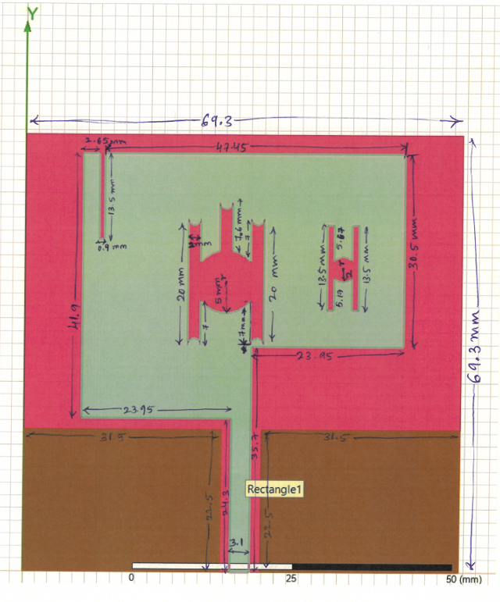

Fig.4: Measurements of the Antenna Model

* **S Parameter Results (S11):**

Fig.5. S11 Parameters Graph

* **3D Radiation Patterns:**

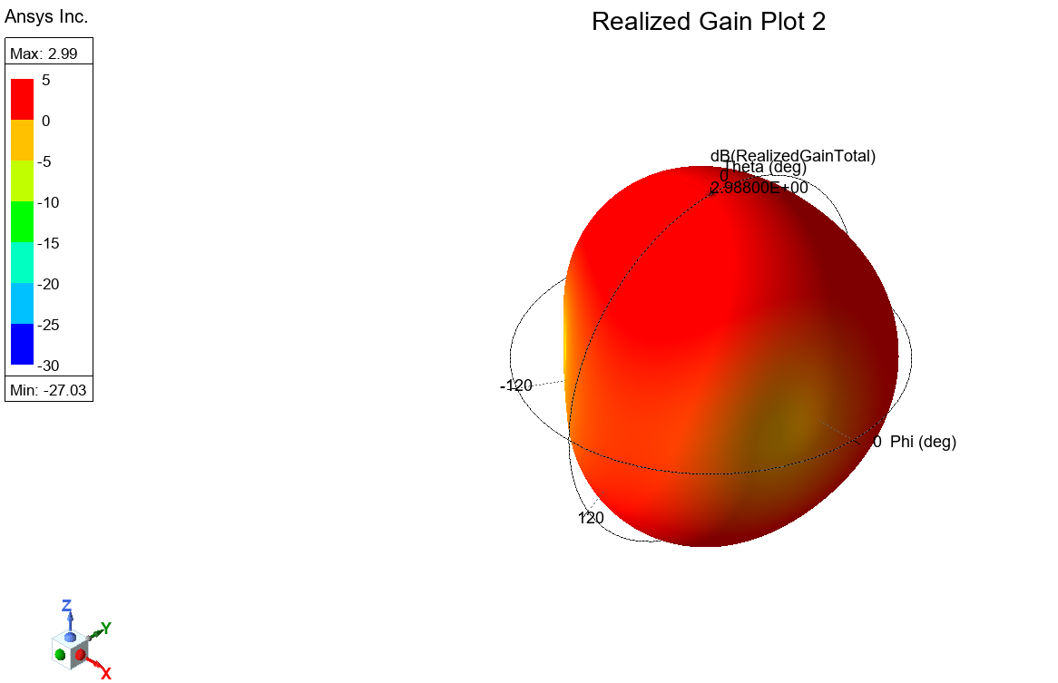

**Fig 6: Realized gain at 2.49GHz**

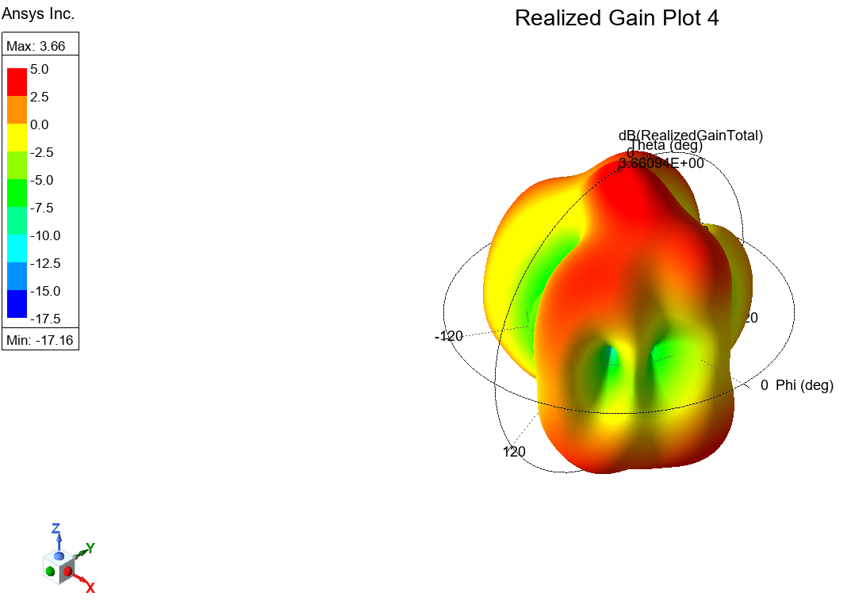

**Fig 7: Realized gain at 5.62GHz**

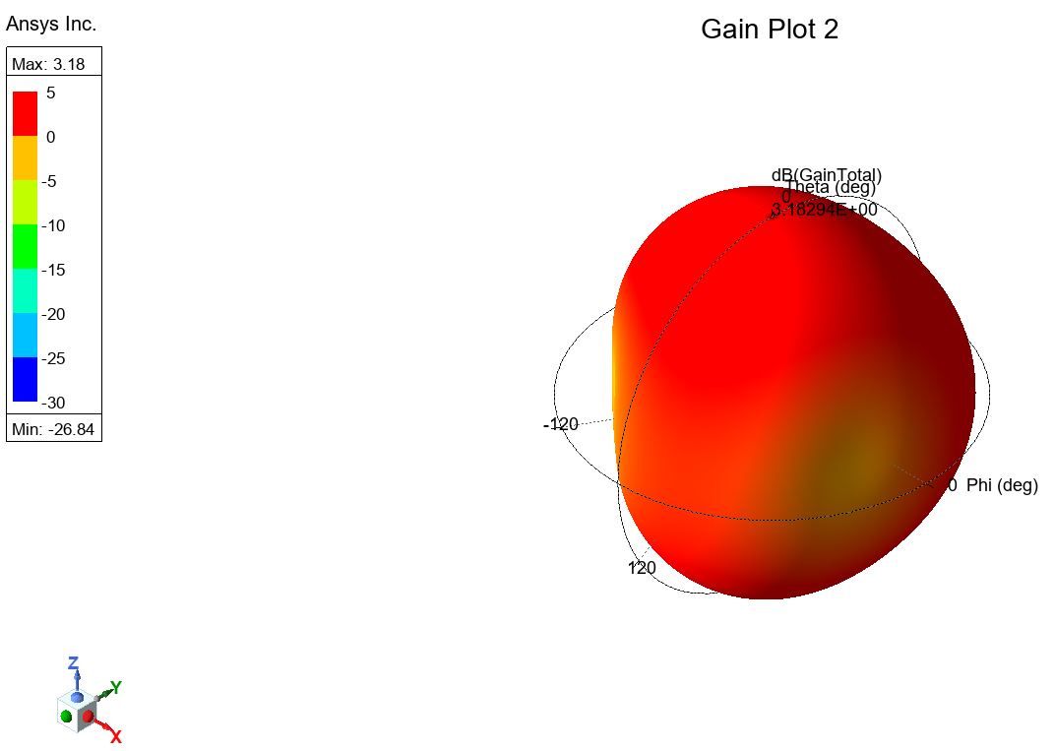

**Fig 8: Gain at 2.49GHz**

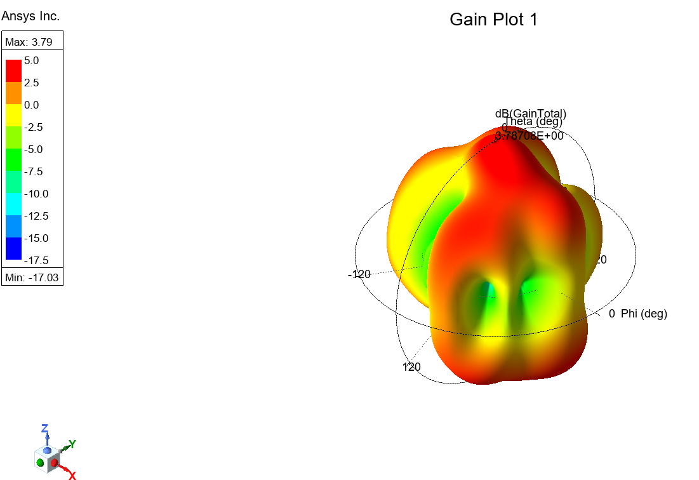

**Fig 9: Gain at 5.62GHz**

* **Gain vs. Frequency Graph**

Fig.10. Gain vs. Frequency

* **Peak Realized Gain vs. Frequency Graph**

Fig.11. Realized Gain vs. Frequency

1. **Conclusion:**

The developed microstrip patch antenna featuring an arced H-slot operates well throughout both Wi-Fi frequency ranges, offering sufficient bandwidth, linear polarization, and satisfactory gain. The designed physical dimensions are within the specified 100 mm x 100 mm × 50 mm limit.

The effort we made begins with an architecture inspired by a paper from the IEEE Xplore collection. After a lot of modifying parameters to match our requirements, we found out that the original article was incorrect and most likely faked. As a consequence, we dropped that approach and shifted to a completely new design within a limited time frame. Although we had been unable to achieve the level of gain we wanted continuously across all parameters, we generated great progress and tried every detail we could to enhance the antenna's quality.

During the entire procedure, we simulated and learned over a variety of antennas structures and techniques for design. It has significantly improved our understanding of RF antenna design and will undoubtedly be beneficial to forthcoming work in the RF field.

**7. References:**

* **Textbook Antenna Theory Analysis and Design CONSTANTINE A. BALANIS**

[**https://mrce.in/ebooks/Antenna%20Theory%20Analysis%20&%20Design%204th%20Ed.pdf**](https://mrce.in/ebooks/Antenna%20Theory%20Analysis%20&%20Design%204th%20Ed.pdf)

* [**https://www.ece.mcmaster.ca/faculty/nikolova/antenna_dload/current_lectures/L14_Arrays2.pdf**](https://www.ece.mcmaster.ca/faculty/nikolova/antenna_dload/current_lectures/L14_Arrays2.pdf)
* [**https://ieeexplore.ieee.org/stamp/stamp.jsp?tp=&arnumber=10170103**](https://ieeexplore.ieee.org/stamp/stamp.jsp?tp=&arnumber=10170103)
* **Dr Hung Luyen Lecture Slides.**